What is recommendation system:

A recommendation system is a subclass of Information filtering Systems that seeks to predict the rating or the preference a user might give to an item. In simple words, it is an algorithm that suggests relevant items to users. E.g.: In the case of Netflix which movie to watch, In the case of e-commerce which product to buy, or in the case of kindle which book to read, etc.

What are recommendations?

* Related item recommendations Similar items
  + Depends on similar items of the current searched items
  + No track of user history
* Home page recommendation
* Personalized

Depended on the user history + Similar items

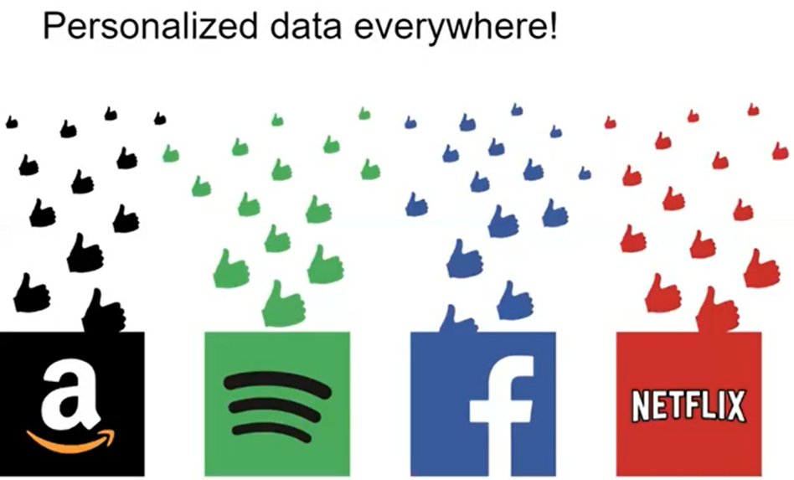

Candidate generation approaches

* Absolute Simple
* Recommend an item based on its own popularity, regardless of the user
* Experience centric
* Content based
  + Based on meta data
  + Based on the history of the user preference
  + Not taking advantage of the other user’s similarity
* Collaborative
* Takes advantage of similar users’ history
* In addition to the same user past preferences, to recommend new items
* And improvement that model to base on item popularity
* we use recommender in chatbot ‘chatbot with recommender’ then the approach we used is content based on meta data method.
* Meta data:
  + Suppose a user enter the field of courses we recommend similar courses.
  + Similar based on what? Meta data
  + Here we assume the user vector = input the user enter that (the field of courses).
  + 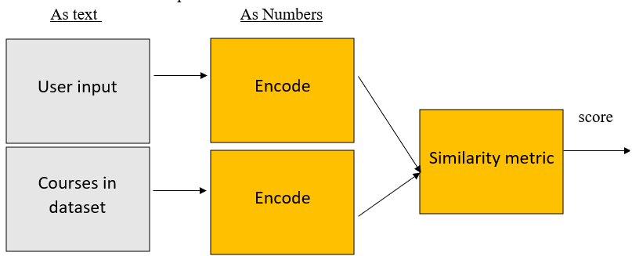How similar between input and courses in meta data?
* In our application we use content base that show similar course when user input with meta data in our dataset.
* We use recommender in chat bot so Related item recommendations (similar items).
* We use dataset ‘udemy_tech.csv’, it has 9963 courses it have feature[title,summary,rating,enrollments,links,stars,index].

We get recommendation from get_ recommendation function

* Try recommender with input ‘flutter courses.

